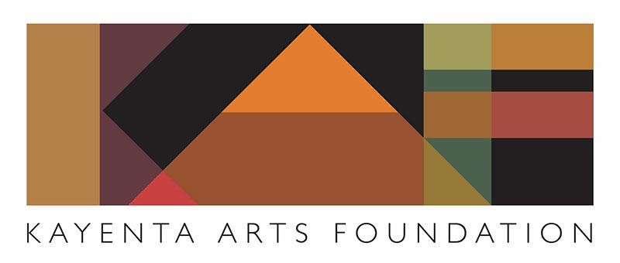

Call for Artists
2023 Street Painting Festival
April 15 and 16

The 2023 Kayenta Arts Foundation’s Street Painting Festival will be held April 15-16. The theme this year is Celebrating Community. Space is limited so artists will be admitted on a first-come, first-served basis. We expect between 15-20 artists to participate in this year’s Festival, and approximately 10 school teams. Awards will be given for Officials Choice and Best of Show, with $500 to the winner and $250 to the runner up for each category. All art must be portrait orientation. Here is what you can expect:

At the Festival:
- Squares will range in size from 8’ x 8’ to 10’ x 10’, depending on the response we get from sponsors. Artists will be assigned to a space within the Art Village.
- Registration will be between 1:00 and 4 p.m. on Friday, April 14th, and 8:00 a.m. on Saturday. You may prep your work surface on Friday afternoon if you wish (cleaning, border, gridding), but your artwork may not commence until Saturday. Judging and the awards ceremony will take place Sunday afternoon.
- Student teams may be interspersed with adult artists to enrich the experience for all.
- Refreshments will be provided on Saturday and Sunday.
- Pastel chalk will be provided; these are the only materials permitted. Use of tempera or any other chalk will disqualify you from the Festival.

Lodging: If you are from outside the area and require lodging, please let us know. We have a team that will work to arrange overnight lodging for you.

Sponsors: KAF will make every effort to find sponsors for your art. You are not responsible for providing your own sponsor, but if you have worked with someone in the past and they are willing to support you again, please let us know the sponsor’s name and amount of sponsorship as early as possible. Kayenta Arts Foundation will be responsible for marking your sponsor’s name at your square. If you need a sponsor form, let us know and we will forward that to you.

Due to space limitations, it is imperative that we have your commitment to participate no later than March 1, 2023. To register and reserve your space, please complete the following form and submit it to Kayenta Arts Foundation, SPF 2023, 881 Coyote Gulch Court, Ivins, Utah 84738. Or you may email the requested information to Festivals@KayentaArts.com

Any questions about the Festival may be directed to the Festival Director, Todd Prince, at Festivals@KayentaArts.com

2023 Street Painting Festival: Celebrating Community
Artist Registration

Artist Name:

Address:

E-mail:

Telephone #:

Additional team members:

Proposed art subject:

Please submit this form by March 1, 2023 to:
Email to: Festivals@KayentaArts.com

Or send hard copy to:
KAYENTA ARTS FOUNDATION
SPF 2023
881 COYOTE GULCH COURT
IVINS, UTAH 84738

Be a Part of the Art!

